1. A screenshot of a computer

   Description automatically generated
2. Even though we can use any text editor for writing OpenAPI Specification but we will use **Swagger Editor** as it provides inline suggestions, syntax errors etc.
3. Download Swagger Editor:  
   A screenshot of a computer

   Description automatically generated
4. There are multiple ways when coming to Swagger Editor.
   1. We can do local setup after downloading the tool.
      1. Set up tools in your network so that you can control that the information is not going outside your company.
   2. We can use Browser version too. (For learning purpose, we will use this).
   3. We can also deploy in cloud.
5. A screenshot of a computer

   Description automatically generated
6. 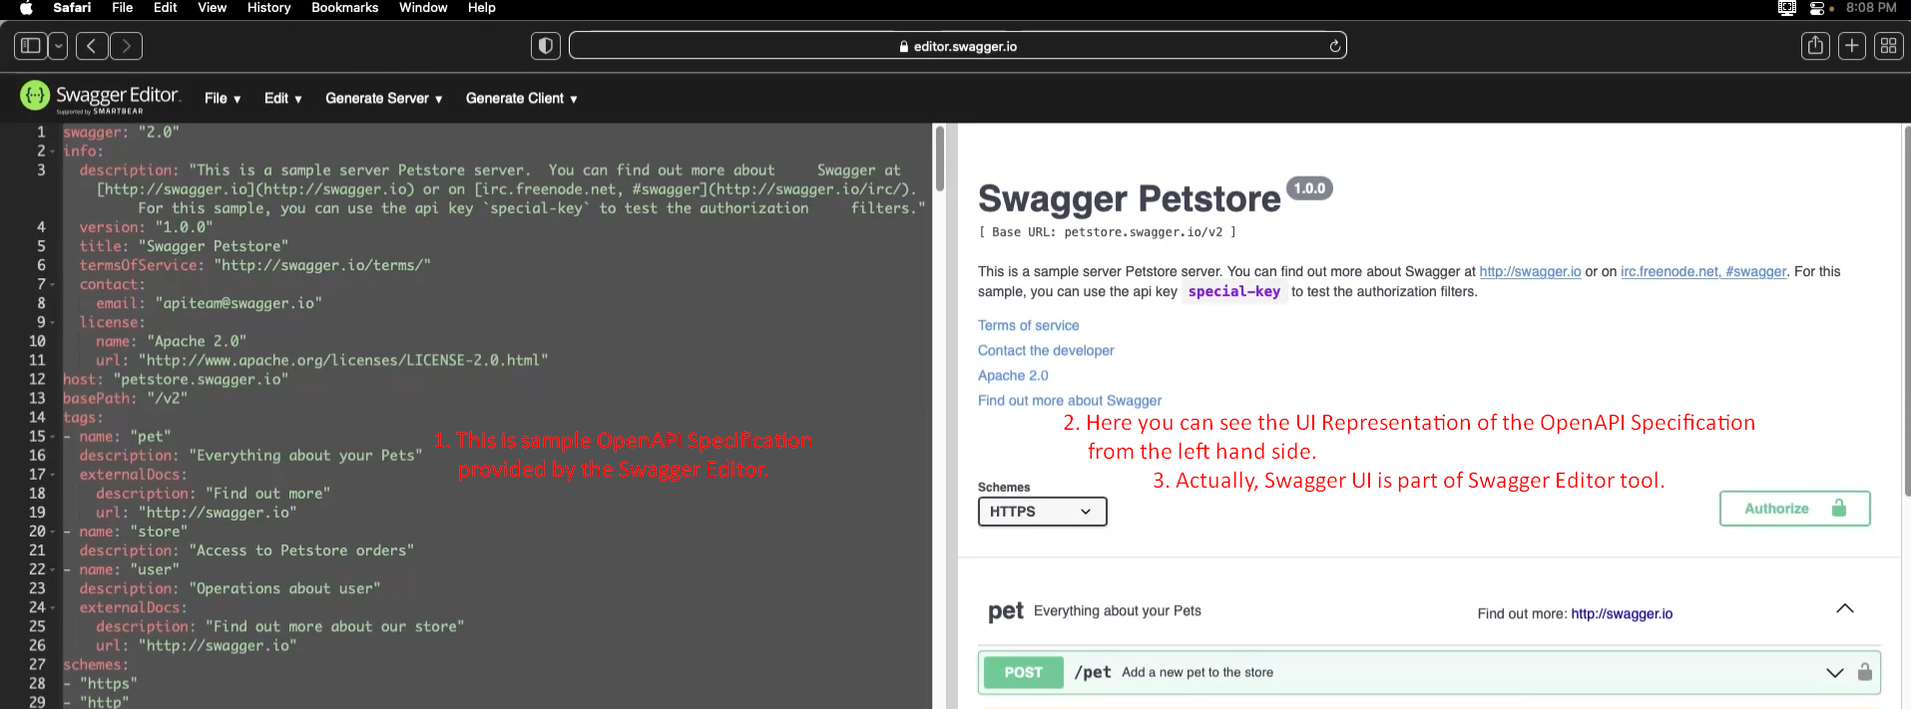
7. A screenshot of a computer

   Description automatically generated
8. A screenshot of a computer error message

   Description automatically generated  
   Above the error msg “Structural error at”, after “at” there is nothing, it means the property is missing at the root level of the yaml file.
9. See, now below no error as we have provided all the mandatory properties which are mi  
   A screenshot of a computer

   Description automatically generated
10. We can download the specification from below.  
    